How to Remove duplicate rows by using ADF between two files

Requirements:

1. Create dataflow activity & 2. Create second dataflow activity for second file purpose
2. After dataflow add Union
3. After Union add aggregate
4. After aggregate add sort
5. After sort add sink dataset then debug it.

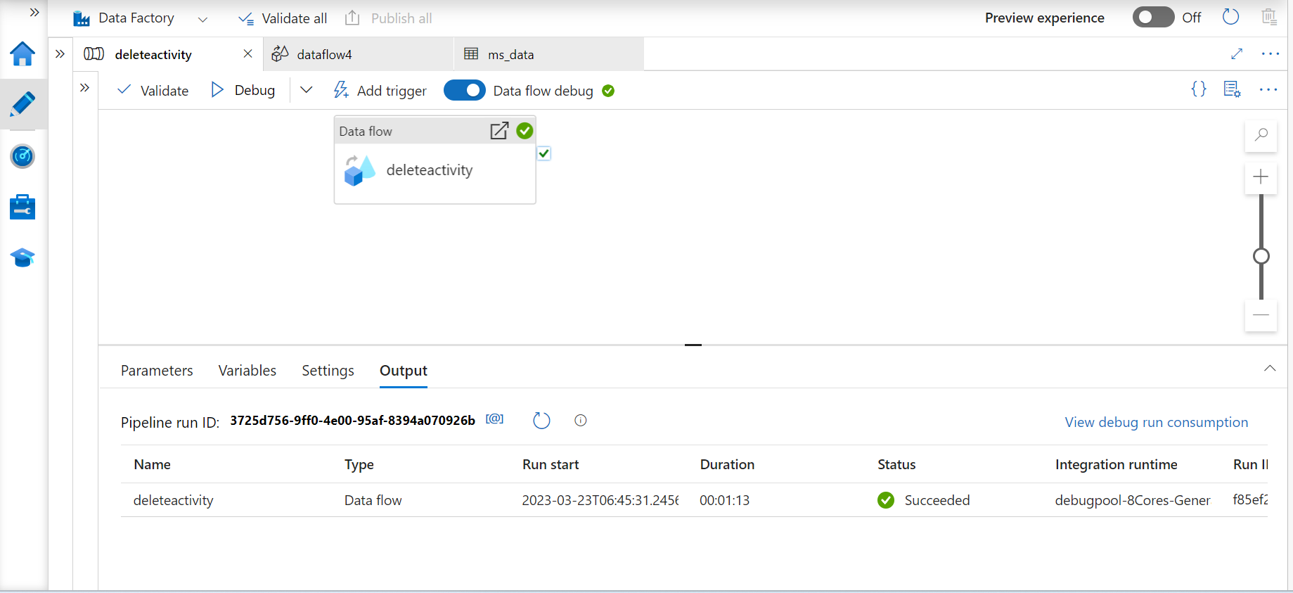

Delete Null values by using exists

Requirements:

